**AI Network Architectures Pre-Assessment**

Question 1

Which load-balancing method optimizes AI/ML workloads in an Ethernet environment?

Parte superior do formulário

* stateless ECMP
* load based on link congestion
* packet spray and reorder
* round-robin

Question 2

Why is nonblocking fabric essential in AI/ML networks?

Parte superior do formulário

* It decreases the importance of GPU performance.
* It eliminates the need for congestion management.
* It ensures full-rate connectivity between hosts.
* It reduces the number of required NICs.

Parte inferior do formulário

Question 3

Which network topology is optimal for AI/ML workloads due to its scalability and consistent performance?

Parte superior do formulário

* star topology
* ring topology
* Clos (leaf-spine) topology
* bus topology

Parte inferior do formulário

Question 4

What is the primary reason for using multiple GPUs in AI/ML workloads to handle large datasets?

Parte superior do formulário

* to achieve reasonable job completion times
* to minimize hardware costs
* to reduce power consumption
* to simplify software development

Question 5

What is the benefit of using a hybrid connectivity approach in AI/ML data centers?

Parte superior do formulário

* It eliminates the need for RDMA.
* It optimizes performance, scalability, and cost-efficiency.
* It reduces the need for network security.
* It simplifies network management.

Question 6

What are the benefits of using optical cables instead of copper cables in data centers?

Parte superior do formulário

* Optical cables are cheaper than copper cables.
* Optical cables are easier to install.
* Optical cables are more flexible than copper cables.
* Optical cables offer longer reach, smaller diameter, and higher data rates compared to copper cables.

Parte inferior do formulário

Question 7

Which factor is a challenge for isolated networks?

Parte superior do formulário

* high scalability
* high reliability
* complete control over the network infrastructure
* maximum security

Parte inferior do formulário

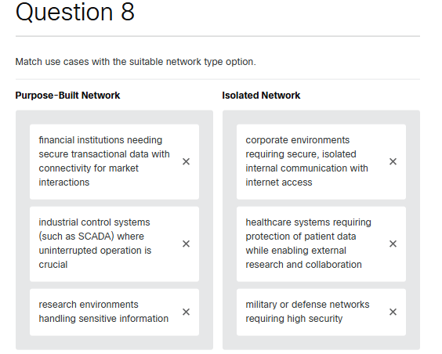Parte inferior do formulário

Question 9

What is the primary benefit of the three-tier hierarchical model compared to the two-tier hierarchical model?

Parte superior do formulário

* It enhances scalability by enabling the addition of more leaf and spine switches without significant restructuring.
* It offers significant modularity and flexibility for policy implementation and traffic management.
* It provides lower latency through direct, single-hop connectivity between devices.
* It simplifies management and troubleshooting by reducing the number of network layers.

Parte inferior do formulário

Question 10

Which layer of a fog computing system is responsible for local data processing and is closest to the data sources?

Parte superior do formulário

* cloud layer
* core layer
* edge layer
* fog layer

Parte inferior do formulário

Question 11

Which two options describe how VXLANs enhance the scalability of AI networks compared to traditional VLANs? (Choose two.)

Parte superior do formulário

* VXLANs directly increas the physical network bandwidth by aggregating multiple links.
* VXLANs extend VLANs over Layer 3 networks to enable more virtual networks and scalable network virtualization across geographically dispersed data centers.
* VXLANs enhance local network performance without impacting scalability or virtualization.
* VXLANs replace VLANs by eliminating the need for network segmentation in AI environments.
* VXLANs simplify network management by reducing the number of required physical switches in the data center.
* VXLANs support large-scale AI deployments by providing a more flexible and scalable network architecture to accommodate the high demand for cloud-based AI services.

Question 12

What is the primary benefit of fog computing in the context of distributed processing for AI?

Parte superior do formulário

* It processes data locally, which is crucial for real-time applications.
* It centralizes data processing in the cloud.
* It increases data that are sent to the cloud.
* It restricts the ability to scale resources dynamically.

Question 13

What are two potential issues that can arise from connecting AI servers to non-optimized networks? (Choose two.)

Parte superior do formulário

* insufficient network bandwidth leading to data bottlenecks
* improved GPU utilization due to faster data processing
* increased network latency affecting data transfer speeds
* enhanced synchronization between GPUs in distributed training
* reduced power consumption due to lower processing demands

Question 14

Which feature of Cisco Nexus 9000 series switches in a spine-leaf topology enhances scalability when additional throughput is needed?

Parte superior do formulário

* adding more leaf switches
* increasing the redundancy of existing switches
* using higher port count leaf switches
* adding more spine switches

Parte inferior do formulário

Question 15

Which network connection option is best suited for the NVIDIA L40S GPU server to ensure optimal performance?

Parte superior do formulário

* connect to 1G Catalyst ports
* connect to a local office router
* connect to 10G Catalyst ports
* connect to data center switches in the HPC environment

Parte inferior do formulário

Parte inferior do formulário

Parte inferior do formulário